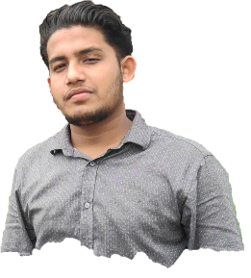Curriculum Vitae­­­

**Name :** Tanvir Ahmed Ovi

**Father’s Name :** Md. Habibur Rahman Sardar

**Mother’s Name :** Tasilma Begum

**Permanent Address :** Village-Borakotha, Post-Dakuar Hat,

Thana-Uzirpur, District-Barishal.

**Present Address :** Village-Badekolmesshor,

Post- National University,Thana-Gacha

District-Gazipur.

**MobileNo : +8801913585905**

**Date Of Birth :** 17 Nov 2002

**Sex :** Male

**Religion :** Muslim

**Nationality : Bangladeshi**

**Educational Qualification :**

|  |  |  |  |  |
| --- | --- | --- | --- | --- |
| Degrees | Group | Boards | Pass. Year | Result(G.P.A) |
| P.S.C |  | Dhaka | **2012** | **5.00** |
| J.S.C | Science | Dhaka | **2015** | **5.00** |
| S.S.C | Science | Dhaka | **2018** | **5.00** |
| H.S.C | Science | Dhaka | **2021** | **5.00** |

**Computer experience:** I am a Professional Web Designer and WordPress Expert since 2020.I have done lots of projects in local market place. Now a days I am trying to work Fiverr. And Upwork market places. Here is my Portfolio website- <https://tanvirahmedovi.com/>

Date- Signature

(Tanvir Ahmed Ovi)